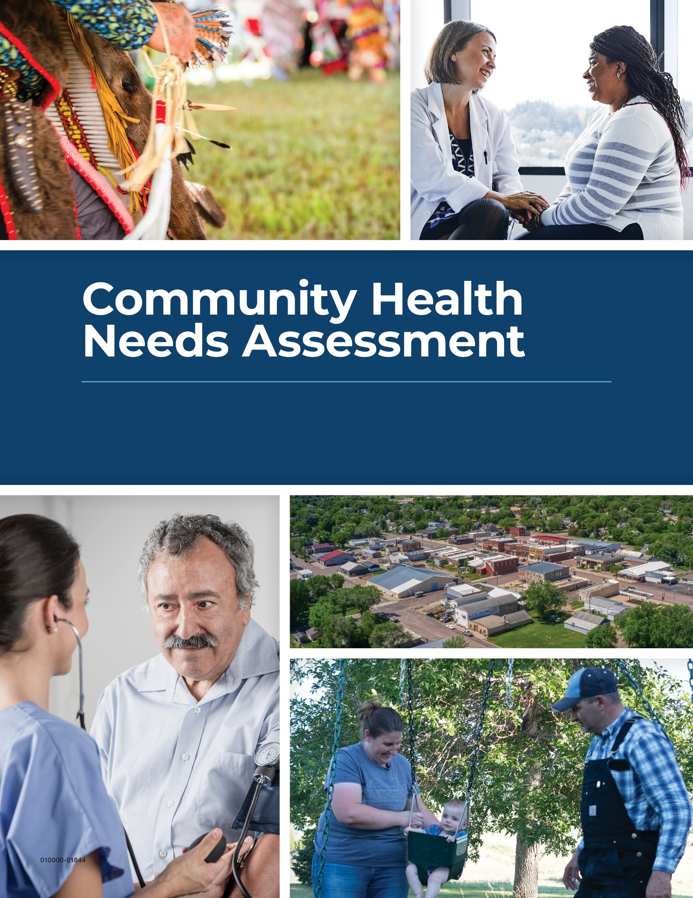

Pioneer Memorial hospital
2026-2028

BACKGROUND

Community Description
The town of Viborg, population 793, is located in the southeastern corner of South Dakota in
Turner County, population 8,708. The community’s proximity to Sioux Falls and Yankton makes Viborg an ideal location for those who want a rural lifestyle while having easy access to city amenities. Residents and visitors to Viborg enjoy stunning landscapes, local eateries, city parks, and movies at the Lund Theater. Several state parks are close by including Lewis and Clark Recreation Area, Newton Hills State Park, and Union Grove State Park.

The community as defined for purposes of the Community Health Needs Assessment includes Turner County, South Dakota. Demographic detail for the county is included in the appendix.

Partners
The Community Health Needs Assessment builds on the work of previous cycles and is the result of the coordinated efforts of many internal and external partners. We would like to thank and acknowledge the following and their teams for their assistance. This program would not be possible without their expertise.

Community Partners
We express our gratitude to the following community collaborative members for their expertise during the planning, development and analysis of the community health needs assessment:
- Isaac Gerdes, CEO
- Anne Christiansen, CFO
- Sydney Blaine, Activities Manager
- Kaity Hansen, Director of Social Services PMH&HS
- Lori Hisel, Director of HR and Support Services
- Patti Timmermans, Director of Therapy
- Felicia Pease, Dietary Manager
- Kayla Mehlhaf, Provider
- Tonya Rudd, Clinic Director
- Jennie Boe, Laboratory Manager
- Amanda Jans, Director of Nursing – Long Term Care
- Brett Mellem, Viborg-Hurley Public School Superintendent
- Stacey Sorlien, Director, Marketing

Sanford Health
- Erika Batcheller, Executive Vice President, Chief External Affairs Officer
- Nick Olson, Executive Vice President, Chief Financial Officer
- Corey Brown, Senior Vice President, Government Affairs
- Amber Langner, Senior Vice President, Treasury
- Blayne Hagen, Vice President, General Counsel, Sioux Falls
- Lindsay Daniels, Vice President, Care Management
- Doug Nowak, Vice President, Data Analytics
- Natasha Smith, Head of Diversity, Equity and Inclusion
- Catherine Bernard, Director, Tax
- Karla Cazer, Clinical Nurse Specialist, Faith Community Nursing Center
- Deana Caron, Senior Tax Accountant
- Kurt Brost, Senior Director, Community Relations
- David Hill, Director, Chief Privacy Officer
- Jessica Sexe, Senior Director, Communications
- Phil Clark, Director, Marketing Insights
- Shawn Tronier, Lead Marketing Analyst
- Chase Gerar, Strategic Planning Advisor, Fargo
- Brian Ritter, Head of Market Affairs, Bismarck
- Kayla Winkler, Lead Community Relations Specialist, Bemidji

Regional Partners
- Sister Nancy Miller, Director Mission Integration, CHI St. Alexius Health
- Julie Ward, VP of Diversity, Equity & Inclusion, Avera McKennan Hospital & University Health Center
- Angela Schoeffelman, Community Program Manager, Avera Community Health Resource Center
- Alli Fast, Community Health Program Manager, Essentia Health
- Nancy Hodur, Director, North Dakota State University Center for Social Research
- Karen Olson, Research Specialist, North Dakota State University Center for Social Research
- Kathy McKay, Public Health Administrator, Clay County Public Health
- Desi Fleming, Director of Public Health, Fargo Cass Public Health
- Justin Bohrer, Public Health Analyst & Operational Planning Lead, Fargo Cass Public Health
- Julie Sorby Engen, Director of Community Development, Family HealthCare
- Shelby Kommes, Public Health Coordinator, Sioux Falls Health Department
- Renae Moch, Public Health Director, Bismarck-Burleigh Public Health and Immediate Past President, North Dakota Public Health Association
- Erin Ourada, Administrator, Western Plains Public Health
- Joe Kippley, Public Health Director, Sioux Falls

Pioneer Memorial Hospital & Health Services Description
Established in 1959, Pioneer Memorial Hospital and Health Services has long been serving the community of Viborg and the surrounding area. Pioneer Memorial Hospital is a 12-bed, critical access acute and swing bed care, community non-profit hospital that serves the residents of Turner County and the surrounding area. PMHHS also includes Viborg Medical Clinic, Centerville Medical Clinic, and Parker Medical Clinic, all certified rural health clinics, a 52-bed skilled nursing facility, 10-unit assisted living facility, and 20-unit independent living facility.

Pioneer Memorial has two physicians and four advanced practice providers on staff and several outreach specialists who travel to Viborg to serve local patients and residents.

The hospital’s mission - “Committed to health, healing and community” - is complementary to its values of compassion, safety, quality of care, and fiscal responsibility as it aims to be a proactive force in the community to changing needs. Pioneer Memorial is governed by a nine-member Board of Directors.

CHNA Purpose
The purpose of a community health needs assessment is to develop a global view of the population's health and the prevalence of disease and health issues. Findings from the assessment serve as a catalyst to align expertise and develop a Community Investment/Community Benefit plan of action. There is great intrinsic value in a community health needs assessment when it serves to validate not-for-profit status and create opportunity to identify and address public health issues from a broad perspective. A community health needs assessment identifies the community’s strengths and areas for improvement. A community health needs assessment is critical to a vital Community Investment/Community Benefit Program that builds on community assets, promotes collaboration, improves community health, and promotes innovation and research. It also serves to support progress made toward organizational strategies.

Regulatory Requirements
Federal regulations stipulate that non-profit medical centers conduct a community health needs assessment at least once every three years and prioritize the needs for the purpose of
implementation strategy development and submission in accordance with the Internal Revenue Code 501(r)(3).

The Internal Revenue Code 501(r) requires that each hospital must have: (1) conducted a community health needs assessment in the applicable taxable year or in either of the two immediately preceding taxable years; (2) adopted an implementation strategy for meeting the community health needs identified in the assessment; and (3) created transparency by making the information widely available.

The regulations stipulate that each medical center take into account input from persons who represent the broad interests of the community. Hospitals are required to seek input from at least one state, local, tribal or regional government public health department or state Office of Rural Health, with knowledge, information or expertise relevant to the health needs of the community.

Non-profit hospitals are also required to seek input from members of medically underserved, low income, and minority populations in the community, or organizations serving or representing the interest of such populations. This includes underserved populations experiencing disparities or at risk of not receiving adequate care due to being uninsured or due to geographic, language or financial or other barriers.

The community health needs assessment includes a process to identify community resources available to address identified and prioritized needs. Hospitals are to address each assessed need or explain why they are not addressing a need. Once needs have been identified and prioritized, hospitals are required to develop an implementation strategy for each. The strategies are reported on the IRS 990 and a status report must be provided each year on IRS form 990 Schedule H.

Finally, hospitals are required to be transparent with the findings and make the written CHNA report available to anyone who requests it. All CHNA reports and
implementation strategies are housed on the hospital’s website at https://www.pioneermemorial.org/. Hospitals must keep three cycles of assessments on their website.

The organization extended a good faith effort to engage all aforementioned community representatives in this process. We worked closely with public health experts throughout the entire assessment process. Public comments and responses to the community health needs assessment and the implementation strategies are welcome on the organization’s website or via email/phone at 605.326.5161. No community comments or questions regarding the previous CHNA have been made via the website link or email address.

CHNA Process
Pioneer Memorial Hospital & Health Services worked with Sanford Health to utilize a process developed in coordination with public health experts, community leaders, and other health care providers, within the local community and across South Dakota, North Dakota, and Minnesota to develop a multi-faceted assessment program designed to establish multiple pathways for health needs assessment.

Limitations
The findings in this study provide an overall snapshot of behaviors, attitudes, and perceptions of residents living in the community. A good faith effort was made to secure input from a broad base of the community. However, gaps in individual data sources may arise when comparing certain demographic characteristics (i.e., age, gender, income, minority status) with the current population estimates. For example, these gaps may occur due to the difficulty in reaching respondents through the survey process.

To mitigate limitations, the CHNA evaluates community health from several perspectives: a
stakeholder and community survey, meetings with community leaders that have special knowledge and expertise regarding populations, secondary data sources such as the U.S. Census Bureau and County Health Rankings, public comments from previous assessments, and institutional knowledge by employees.

Community and Stakeholder Survey
Community residents were asked a series of questions through an online survey designed in partnership with health experts and public health officials across the Sanford footprint to understand health needs. Survey design is based on the UW Population Health Institute model. Each respondent was asked to rate community drivers from poor to excellent. Any response other than excellent was offered a follow-up opportunity to comment on the reason for their ranking. Respondents were also asked a series of questions specific to their health care access, health care quality, barriers to care, travel to care, and insurance. The survey was sent to a sample of the Turner County populations secured through Qualtrics, a qualified vendor. The full set of questions is available in the appendix.

The survey was the first of multiple efforts to engage community stakeholders and elected officials with knowledge and connections amongst medically underserved, low income, or minority populations. Members of the local Public Health department were included in the survey distribution list and engaged following the stakeholder survey to review the CHNA and Implementation Plan. Stakeholders were sent the survey and asked to complete the instrument and then forward the survey to their respective populations for greater involvement.

Survey data for the local community should be considered directional and best utilized in conjunction with additional data. A total of 64 respondents from the CHNA area completed the survey. The data was augmented for analysis with responses from other hospitals participating in the CHNA process during the same period.
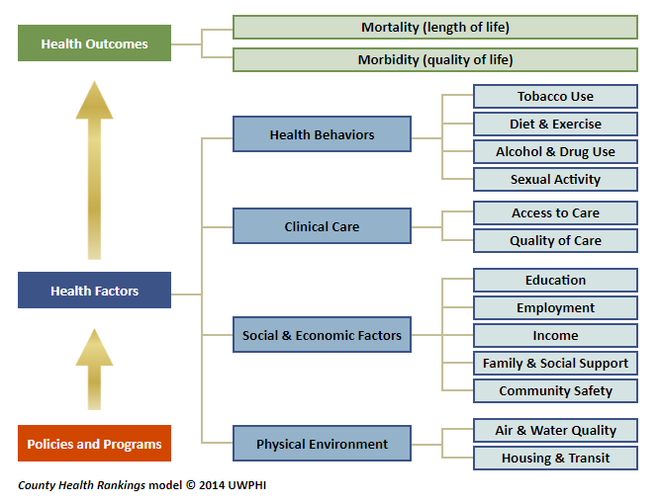
Secondary Data
County Health Rankings are based upon the UW Population Health model and serve as the main secondary data source utilized for the community health needs assessment. Alignment of the survey and secondary data within the UW Population Health model allows for greater connection of the data sets. Population data are sourced to the U.S. Census Bureau. Additional data sources may be used and are sourced within the document.

Health Needs Identification Methodology
The Center for Social Research at North Dakota State University was retained to develop the initial community health needs list for each community, building upon their involvement during the previous cycle. The following methodology was used to develop the significant health needs presented later in the report:
- To identify community health care needs, the community’s score by question was compared to the average stratified composite of a comparative group that completed the survey in other communities within the region, including Murray County and Big Stone County, MN, and Turner, Tripp, and Gregory counties in South Dakota.
- To identify community health care needs, each community’s score by question was compared to the average stratified composite of the comparative group. For example, if the composite stratified system-wide average score is 4 and an individual community’s average response was 2.5, which would suggest an issue of concern and a potential community health care need to be highlighted in the summary findings.
- Upon determination of a potential strength or need, County Health Rankings (https://www.countyhealthrankings.org/) and responses from open-ended questions provided additional insights into the drivers of the respective needs.
- A similar methodology was also used to provide additional insights into findings from County Health Rankings data with relevant health needs highlighted in the survey findings.
- Health needs identified through either the survey or County Health Rankings data but not both were also included in the findings.
- The Center for Social Research validates the findings of the primary research by engaging at least two internal reviewers. Each reviewer has their own technique and strengths to review the findings; however, they check for accuracy in the data by reviewing the code/syntax, the output, the correct representation of the data in the report, verbiage, consistency, context, and overall readability. Both reviewers also supported previous CHNA reports.

Community Asset Mapping
Asset mapping was conducted to locate community resources available to address the assessed needs. Each unmet need was researched to determine what local resources are available. Once gaps were determined, the prioritization exercise followed with key stakeholder groups determining top needs for their community.

Community Stakeholder Meetings
Community stakeholders and elected officials with knowledge and connections amongst medically underserved, low income, or minority populations were further included in the process during the community stakeholder meetings. During the meetings, survey findings were presented to community stakeholders. Facilitated discussion commenced and each participant was asked to consider the needs identified that should be further developed into implementation strategies. Health needs identified during the previous cycle but not raised through the survey or County Health Rankings were also considered. The meeting served to inform the group of the findings but also served as a catalyst to drive collaboration and prioritization of local needs.

The participants provided information to answer the following types of questions as it relates to identified needs:
- What are the biggest challenges currently with these needs in the community?
- Does the community have gaps in services, access, outreach, etc.?
- What opportunities exist, where can we have greatest impact in addressing these needs?
- Which are most urgent in nature?
- Is there already work being done on these needs?
- What are the resources currently not utilized within the community that could address this topic?

Which needs fall within the purview of health care system and which do not? Can the non-healthcare needs be shared with other entities or organizations?
Is there anything you consider an urgent need that we have not discussed?

Following the meeting the hospital administrator and staff identified the specific health needs to be addressed within the Implementation Plan. Administrator recommendations are based on all factors, including primary and secondary data, input from the community stakeholder meeting, and scalability of current hospital programs and resources to address the identified needs efficiently and effectively. All identified needs not addressed in the implementation plan were shared with other community partners for action.

COMMUNITY HEALTH NEEDS ASSESSMENT FINDINGS

Pioneer Memorial Hospital & Health Services in Viborg, SD is an independent organization that contracts with Sanford Health for certain services, including support for the Community Health Needs Assessment. Pioneer Memorial Hospital & Health Services completes a community health needs assessment (CHNA) every three years to assist in identifying unmet health needs in the community, and then strategically plans how to best address those needs. As part of this effort, from February through May 2025, residents of the Pioneer Memorial Hospital & Health Services market area were invited to complete an online community survey to help identify unmet health needs across a range of social determinants of health. Pioneer Memorial Hospital & Health Services, Sanford Health, and the NDSU Center for Social Research partnered to analyze data from the primary survey research along with key secondary data points as part of the CHNA process.
For the purposes of this assessment, the Pioneer Memorial Hospital & Health Services market area is defined as Turner County in South Dakota. The community health outcomes and health needs presented below were identified through a mix of primary and secondary research. Priority was given to the key topics rated lowest by respondents of the community survey, with further analysis provided through secondary research using the 2025 County Health Rankings & Roadmaps (CHR) data. Areas of focus that may not have been raised by the community survey but shown to be an area of focus through secondary research are also included.
Community survey and CHR data were also collected for four similar-sized market areas served by facilities participating in the 2025 CHNA process. Data from all five communities were included in this analysis to further assist in identifying community health needs for Pioneer Memorial. The similar-sized market areas identified for and included in this analysis include those served by the Winner Regional Healthcare Center in Winner, SD; the Community Memorial Hospital in Burke, SD; Ortonville Area Health Services in Ortonville, MN; and the Murray County Medical Center in Slayton, MN. Results were analyzed for each of the five market areas individually and for the group as a whole for comparison purposes.

A total of 64 respondents from the Pioneer Memorial market area completed the survey.

Community Health Outcomes
Survey respondents were asked to rate various issues impacting health in their community and issues impacting their personal health and wellness on the following 1 to 5 scale: 1=poor, 2=fair, 3=good, 4=very good, 5=excellent.

Overall, perceptions among survey respondents in the Pioneer Memorial market area regarding the following community health issues were positive (average score of 3.00 or higher):
- Environmental health (average score=4.33)
- Community safety (average score=4.27)
- Quality of long-term care, nursing homes, and senior housing services (average score=3.91)
- Health care quality (average score=3.75)
- Access to exercise opportunities (average score=3.63)
- Access to healthy foods (average score=3.61)
- Quality early child care (average score=3.56)
- Access to daily transportation (average score=3.36)
Employment and economic opportunities (average score=3.19)
In addition, the average score of survey respondents in the Pioneer Memorial market area for each of these community health issues was higher than the associated comparison group average.

Perceptions among survey respondents in the Pioneer Memorial market area were less than positive for only one community health issue (average score of less than 3.00):
Affordable housing (average score=2.70)
When asked about their personal health, survey respondents in the Pioneer Memorial market area rated their current health and wellness as better than good (average score=3.59) and their current ability to access health care services as very good (average score=3.98) (both scores are higher than the associated comparison group average).

CHR data indicate that Turner County fares better than the average county in South Dakota for personal health and well-being and for community health conditions. The following areas of concern were identified for further discussion (in no particular order).
Identified Health Needs
Access to Health Care Providers
Survey respondents in the Pioneer Memorial market area rated their own ability to access health care as very good (average score=3.98) – a score which is higher than the comparison group average. In addition, most respondents have a primary care provider (76%) and have seen a provider for a routine checkup or screening in the past year (90%). Despite this positive feedback, when respondents were asked about the most important health care issues impacting their community, access to health care was the top issue. Specifically, respondents were concerned about a lack of specialty care and a shortage of health care providers in general.
When asked if they or a family member had traveled to receive health care services outside of their community within the past three years, 66 percent of respondents in the Pioneer Memorial area indicated they had. When asked why, most of those who traveled for care indicated that they needed specialty care or the needed services were not available locally (79%). According to CHR data, there are 4,428 people in the Pioneer Memorial market area for every one dentist (the highest/worst ratio among similar-sized markets and two times higher than the comparison group average) and 4,514 people per mental health care provider (also the highest/worst ratio among similar-sized markets and four times higher than the comparison group average). Currently, data for primary care physicians is unavailable for this market area.
Slightly more than one-third of survey respondents in the Pioneer Memorial area indicated that there are health care services they would like to see offered or improved in their community (38%). When these respondents were asked which health care services they would like to see offered or improved, most said heart care (53%) and dental care (53%), followed by orthopedics and sports medicine (37%), dermatology (37%), behavioral and mental health care (37%), addiction treatment (37%), eye services (32%), cancer care (32%), walk-in/urgent care (26%), OBGYN and women’s care (26%), labor and delivery (26%), long-term care and nursing homes (21%), general surgery (21%), and family medicine/primary care (21%).
During the stakeholder meeting, participants reviewed the hospital’s recent efforts to improve access to care within the community. This included the expansion of services such as dermatology, neurology, and psychiatry through outreach initiatives. While these additions have helped increase access, concerns were raised about the absence of dental services in Viborg and a noticeable reduction in cardiology outreach days. The conversation also touched on community awareness, with several participants questioning whether residents are fully informed about the range of services currently available through the hospital.

Local Asset Mapping
Health Care Resources:  - SD DHS Prescription Assistance Program - 605-773-3656  - SD Medicaid / DSS – 800-305-3064  - Viborg Medical Clinic – 605-326-5201  - Parker Medical Clinic- 605-297-3888  - Centerville Medical Clinic – 605-563-2411  - Home and Community Based Services for Developmental Disabilities (Parker) – 800-305-3064  - Home Health Accessories & Medical Equipment by Sanford Health – 605-624-4955  - Top Gum Dental (Parker) – 605-297-6161  - Neighborhood Dental Beresford – 605-763-5035  - Jason Aanenson, DDS Freeman – 605-925-4999 | Mental Health Resources:  - NAMI SD (Sioux Falls) – 605-271-1871  - SD Human Services Center – 605-665-3100  - Southeastern Behavioral Health (Sioux Falls) -605-336-0510  - Pioneer Memorial Hospital - 605-326-5161  - SD Division of Behavioral Health – 605-367-5236  - Heartland Psychological Services (Yankton) - 605-665-0841  - Human Service Center (Yankton) - 605-668-3100  - Lewis & Clark Behavioral Health (Yankton) - 605-665-4606  - Collective Perspective Counseling (Beresford) - 605-321-0826  - National Suicide and Crisis Lifeline - 988

Access to Affordable Health Care
Cost and the ability to afford needed health care was identified by survey respondents in the Pioneer Memorial market area as the second largest health care concern impacting their community. Despite this concern, survey respondents in the Pioneer Memorial area rated the employment and economic opportunities in their community as good (average score=3.19) (a score which is higher than the comparison group average). In addition, CHR data indicate that the Pioneer Memorial market area has the highest median household income ($75,454), the lowest percentage of people with limited access to healthy foods (1% of people have low income and do not live near a grocery store), the second lowest unemployment rate (2%), the lowest child poverty rate (8%), and the lowest child care cost burden (the average household spends 18% of its income on child care for two children) when compared to similar-sized markets. CHR data also indicate that 10 percent of people in the Pioneer Memorial area are uninsured, a rate which is similar to the comparison group average.

The cost of health care was a topic during the stakeholder meeting, with participants agreeing that it remains a challenge both locally and across the region. Rising deductibles were highlighted as a significant barrier, discouraging individuals from seeking necessary care. While efforts are being made to manage premium increases, such as increased deductibles, the broader issue of affordability persists.

In addition to direct health care costs, participants pointed to the growing financial strain from other household expenses—such as housing and food—which further limits access to care for many in the community.
Local Asset Mapping
- Inter-Lakes Community Action Partnership (ICAP) - 605-940-1909  - Pioneer Memorial Hospital & Health Services and Freeman Regional Health Services - 605.326.5161  - Turner County Family & Community Health Services - (605) 326-5161, | - Community HealthCare Association of the Dakotas (CHAD) - 605.275.2423  - South Dakota Department of Social Services (DSS) - https://dss.sd.gov/contactus/default.aspx

Healthy Living
In the United States, many leading causes of death and disease are attributed to unhealthy behaviors. For example, poor nutrition and low levels of physical activity are associated with higher risk of cardiovascular disease, type 2 diabetes, and obesity. Tobacco use is associated with heart disease, cancer, and poor pregnancy outcomes if the mother smokes during pregnancy. Excessive alcohol use is a risk factor for a number of adverse health outcomes, such as alcohol poisoning, high blood pressure, stroke, sexually transmitted diseases, unintended pregnancy, fetal alcohol syndrome, suicide, interpersonal violence, and motor vehicle crashes.
Survey respondents in the Pioneer Memorial area rated their own personal health and wellness as better than good (average score=3.59) – a score which is higher than the comparison group average. However, when survey respondents were asked about their biggest health care concerns for themselves and their family (concerns they face on a regular basis), chronic health issues were top concerns along with access to health care providers. The most commonly cited chronic health concerns included viral illnesses, diabetes, and obesity/weight. Diabetes is an important marker for a range of health behaviors. CHR data indicate that 8 percent of adults in the Pioneer Memorial area have diabetes and 34 percent of adults have obesity, both of which are slightly lower than the comparison group average.
Regarding tobacco and alcohol usage, CHR data indicate that 16 percent of adults in the Pioneer Memorial area smoke cigarettes (which is slightly lower than the comparison group average) and 24 percent of adults drink excessively (which is similar to the comparison group average).
Healthy living and chronic received significant focus during the stakeholder meeting. Participants highlighted ongoing efforts to increase community screenings, which have been a priority over the past several years. However, it was noted that some built-in opportunities, such as screenings offered during local festivals, may not align with the timing needs of certain individuals. Identifying additional outreach opportunities and expanding community education were suggested as ways to improve screening rates.
The group also discussed youth health initiatives, with schools continuing to emphasize smoking and vaping education. Both school officials and hospital leaders agreed there’s room to expand drug education, particularly for students approaching high school graduation.
Local Asset Mapping
Nutrition Resources:  - SD Long-Term Services and Supports Office – (Vermillion) - 605-677-6800  - Senior Center (Parker) – 605-297-0176  - Commodity Supplemental Food  - Program (CSFP) by Feeding SD – 605-297-4910  - SD Supplemental Nutrition  - Assistance Program (SNAP) – 605-773-3493  - SD WIC (Women Infants and Children) – 605-773-3361  - Turner County Health-Pioneer Memorial Hospital & Health Services  - Public Health – 605-326-3055  - Turner County Health – 605-297-4472  - Northern Turner County Food Pantry - 605-940-1909  - Food Pantry at Centerville Site - 548 Broadway, Centerville, SD 57014  - Feeding South Dakota - (605) 335-0364 | Physical Activity Resources:  - Pioneer Memorial Wellness Center605-326-5161  - Centerville Public School Gym – 605-563-2291  - Ultimate Fitness Beresford – 605-763-8082  - Adult Workout Training – Cory Jacobsen – 605-929-0241  Additional Resources  - Inter-Lakes Community Action Partnership (ICAP) - 605-940-1909  - Rural Office of Community Services (ROCS) - (605) 384-3883

Affordable Housing
There is a strong and growing evidence base linking stable and affordable housing to health. As housing costs outpace local incomes, households not only struggle to acquire and maintain adequate shelter, but also face difficult trade-offs in meeting other basic needs. When the majority of a paycheck goes toward the rent or mortgage, it can be difficult to afford doctor visits, healthy foods, utility bills, and reliable transportation to work or school. This can, in turn, lead to increased stress levels and emotional strain.
Respondents in the Pioneer Memorial area rated the availability of affordable housing in their community as less than good (average score=2.70) — a score which is lower than any other community health issue. When respondents who rated community access to affordable housing as poor or fair were asked why they did so, respondents referenced a limited availability of housing in general, high costs, and lengthy wait lists and tight income restrictions for subsidized housing.
CHR data indicate that 8 percent of households in the Pioneer Memorial area have severe housing problems (i.e., overcrowded, high housing costs, lack of kitchen facilities, or lack of plumbing facilities) and 9 percent of households spend at least 50 percent of their household income on housing costs – both rates are similar to the comparison group average.
Housing costs, like many other expenses, have continued to rise in recent years due to factors such as increased construction costs and limited inventory. Stakeholders agreed with survey findings that show a lack of available rental and purchase options remains a concern.
In addition to housing, rising costs in areas like childcare are placing further strain on household budgets. These financial pressures are making it more difficult for families to afford adequate housing. The group also discussed the challenges and opportunities related to expanding access to affordable daycare, recognizing it as a critical need in the community.
Local Asset Mapping
Low Income Apartments:  - Village Apartments – 605-660-6039  - Danish Villa Apartments – 605-263-3941  - Meadowland Apartments – 1-800-568-2401  - Rosewood Apartments – 605-263-3941  - Viking Court Apartments – 605-263-3941  - Washington Square Apartments – 605-263-3941 | Housing Resources:  - SD Housing Development Authority (SDHDA) – 605-773-3181  - Governor’s House Program  - Southeastern Council – 605-681-8184  - Parker Housing and Redevelopment Commission – (Parker) – 605-297-4918  - Inter-Lakes Community Action Partnership (ICAP) - 605-940-1909  - Parker Housing & Redevelopment - (605) 297-4918

Area of Focus
The significant health needs noted above were brought forward as topics of discussion at the
local stakeholder meeting, which convened a range of community leaders with knowledge of medically underserved, low income, or minority populations. A list of attendees can be found in the introduction. Stakeholders discussed the health needs, potential causes, and provided additional insight for their local populations and community resources. Participants were also encouraged to offer additional needs that may not have been raised during the research process; no additional needs were brought forward.

The Community Health Needs Assessment identified two specific areas for focus for the 2026-2028 implementation cycle:

- Access to Healthcare Providers
- Healthy Living

Implementation Plan for Prioritized Needs

Priority 1: Access to Healthcare Providers

Current Activities
Pioneer Memorial currently Podiatry, Orthopedics, Nephrology, Neurology, General Surgery and Dermatology locally within the community via in-person and virtual services. Providers are involved with community interaction at local events throughout the year. Also, the hospital added telemed services in 2024 for Infectious Disease, Hospice Palliative Care, and Nephrology. Additionally, the hospital has advanced several projects to increase access and understanding of services available locally, including print and social media on the following:
  - Recognized our provider staff during National Doctor Day, National Certified Nurse Practitioner Week and National Physician Assistant Week.
  - Welcome to new provider, Tory Schlaht, CNP.
  - Introduction to Your Local Medical Team
  - At the Viborg Clinic, you can schedule your appointment on Saturday mornings from 9:0 to noon and open until 8:00 pm on Mondays.
  - Well Child Exams
  - Telemed is Available in Viborg.
  - Drive-Thru Flu Shot Clinics

Projected Impact
The projected impact is the community will be better informed as to the healthcare resources and accessibility to available heath care services. Two goals were identified: (1) The Community will become more aware of provider availability and access to health care resources, and (2) Ensure clinic hours and specialty availability via telemedicine meet the needs of the served population.

Goal 1: Improve access to services

Action/Tactic | Measurable Outcomes & Timelines | Resources | Leadership | Community Partnerships and Collaborations - if applicable
Increase specialty services offered in person or via telehealth | 2026-2028, expand specialty care offerings to the community and track number of patients impacted | Pioneer Memorial leadership staff time | Pioneer Memorial Hospital & Health Services Leadership and Medical Staff

Goal 2: Expanded access to mental health and behavioral health care

Action/Tactic | Measurable Outcomes & Timelines | Resources | Leadership | Community Partnerships and Collaborations - if applicable
Expand Integrated Health Therapist Resource | 2026-2028 implementation – IHT Appointments | Staff Time | Pioneer Memorial Hospital & Health Services Leadership and Medical Staff
Expand overdose support services | Post Overdose Response Team implemented in 2026 – Residents served | Staff Time | Pioneer Memorial Hospital & Health Services Leadership and Medical Staff | Emily’s Hope
Community education program on overdose services | Education set to begin in 2026 – Residents served | Staff time, production costs | Staff

Priority 2: Healthy Living

Current Activities
Sponsored the DXA Weight Loss Challenge to promote weight loss and healthy lifestyle with 30 participants. Mobile mammography services were offered and promoted at Centerville Medical Clinic and Parker Medical Clinic. The hospital sponsored heart and vascular screening at Pioneer Memorial Hospital on February 1, 2024 and on July 18, 2024. Offered CMP and Lipid Panel at a reduced cost at the Spring Fling Event on April 9, 2024. Kids activities, including first aid kits and Blood Pressure checks were available at Danish Days Open House on July 18, 2024. The hospital sponsored a Health Fair on 10/14/2024 with free blood pressure checks, flu shots, vision screening, skin cancer screening, build a first aid kit, and CPR demonstration, Medicare 101 education, and lab test specials (CMP and Lipid Panel). Participated on the community committee to be certified in the South Dakota Cardiac Ready Communities Program. Additional events included sponsoring Heartsaver Training on February 2, 2024 and hosting spring and fall blood drives. The hospital also provided education via print and social media on the following:
  - Awareness for Cervical Cancer, Colorectal Cancer, Lung Cancer, Breast Cancer, Heart Health, Infection Prevention, Glaucoma, Parkinson’s, and Mental Health
  - Screenings for: Heart and Vascular; Lung, and Skin Cancer
  - CPR and AED Awareness
  - Heart Healthy at Any Age
  - Viborg-Hurley Elementary Bike to School Day
  - Well-Child Exams
  - Immunizations and vaccinations
  - Halloween Safety Tips
  - Healthy Aging
  - Suicide Prevention
  - Cholesterol Education

Projected Impact
The projected impact is to increase the awareness and availability of healthy living opportunities in the communities. Two goals were identified: (1) Add additional health prevention services in Parker and Centerville while still offering at Viborg, and (2) Educate, promote and offer healthy living opportunities to area communities.

Goal 1: Physical Activity and Balance

Action/Tactic | Measurable Outcomes & Timelines | Resources | Leadership | Community Partnerships and Collaborations - if applicable
SAIL Program (Staying Active and Independent for Life) | 2026-2028, offer the SAIL program to the community and monitor number of community members impacted | Pioneer Memorial Staff member time | Pioneer Memorial Hospital & Health Services Leadership and Medical Staff | SAIL program leader training

Goal 2: Increase number of patients engaging with dieticians to improve nutrition.

Action/Tactic | Measurable Outcomes & Timelines | Resources | Leadership | Community Partnerships and Collaborations - if applicable
Support access to dietician visits in the outpatient setting | 2026-2028, patient utilization of dietician services, number community members impacted | -Pioneer Memorial Medical staff time  - Access to a Registered Dietician | Pioneer Memorial Hospital & Health Services Leadership and Medical Staff
Explore community partnership to expand access to locally grown healthy food options | 2026 evaluate potential partnership opportunities with a final decision TBD | Pioneer Memorial Staff member time | Pioneer Memorial Hospital & Health Services Leadership and Medical Staff | TBD based upon scoping

Needs Not Addressed

Below are the needs identified during the CHNA process that are not prioritized in the preceding implementation plan were deemed to be less urgent in nature, are being addressed by other community individuals, resources, or organizations, or the hospital does not currently have the appropriate resources to prioritize the work at this time.

Although not included in the Implementation Plan, the hospital supports efforts to address community needs, such as viewing the information collected within the Community Health Needs Assessment as a community benefit and sharing survey and assessment information with community partners to support the expansion or establishment of programs that reduce community needs.

Access to Affordable Healthcare
Affordability remains part of the hospital’s ongoing operational efforts. PMH works with patients who do not have health insurance and assists them to find an appropriate plan or government program to improve their ability to afford care. The local health systems provide essential medical services within the county, which can help reduce travel costs associated with care. Due to current operational efforts in the space, the need was determined to be a lesser priority for purposes of the CHNA.

Affordable Housing
Affordable housing is not included in the Implementation Plan as other organizations, including those listed in the asset map, are better positioned or already meeting the need and have the expertise and competencies to effectively engage in the issue. The hospital is prepared to support community efforts on economic development, workforce and housing needs. Information from the CHNA process will be shared with community partners as requested.

EVALUATION OF 2023-2025 CHNA

This summary highlights the key accomplishments that supported two priority areas: Access to Health Care Providers and Healthy Living Opportunities. All activities directly aligned with the goals and projected impacts outlined in the action plan.

Access to Health Care Providers
Projected Impact: Improve community awareness of available healthcare resources and enhance access to services.
Goals:
- Increase awareness of provider availability and health care resources.
- Ensure clinic hours and specialty access—including telemedicine—meet community needs.

Summary of Achievements:
- Increased visibility of providers through social media, print recognition, and introduction of new staff.
- Promoted extended clinic hours and telemedicine availability, including new services in Infectious Disease, Hospice/Palliative Care, and Nephrology.
- Enhanced community engagement by involving providers at local events.
- Shared information on Well-Child exams, flu shot clinics, and other accessible services.

Overall Impact: Residents are now better informed about how and when to access providers, services, and specialty care—with expanded telemedicine improving access across the region.

Healthy Living Opportunities
Projected Impact: Increase awareness and availability of healthy living opportunities across the communities served.

Goals:
- Expand preventive services in Parker and Centerville while maintaining services in Viborg.
- Educate, promote, and offer healthy living opportunities to area communities.

Summary of Achievements:
- Expanded preventive screenings through mobile mammography, heart and vascular screenings, reduced-cost labs, and a comprehensive community Health Fair.
- Sponsored community wellness programs including the DXA Weight Loss Challenge, Heartsaver Training, blood drives, and children’s health activities.
- Provided extensive education through print and social media on cancer awareness, heart health, mental health, safety topics, immunizations, and healthy aging.
- Participated in the South Dakota Cardiac Ready Communities certification effort.

Overall Impact:
Communities experienced increased access to preventive services and received broad education on healthy living, strengthening overall community wellness.

Conclusion
Across both priority areas, the organization successfully met its projected impacts by improving healthcare access, expanding preventive services, and delivering comprehensive health education. These efforts collectively support healthier, better-informed communities throughout the service area.

CONTACT INFORMATION
The Community Health Needs Assessment, Implementation Plan, and survey data are available online at https://www.pioneermemorial.org/. The website includes current and historical reports.

Anyone wishing to receive a free printed copy, obtain information on any topic brought forth in the report, or offer public comments for consideration during the implementation plan or future Community Health Needs Assessment work, please contact us at <<insert>>.

APPROVAL
The information presented in the Community Health Needs Assessment and
Implementation Plan were approved by the Pioneer Memorial Hospital Board of Directors on December 11, 2025.
APPENDIX
Expanded Demographics
Turner County had a population of 8,144 in 2021. The population remained relatively flat (0.4% increase) from 2010-2019. The population is slightly older than the state average with 21% of residents over the age of 65, versus 17.5% for the state of South Dakota. The county is less racially diverse than the state average in every demographic with 96.8% of residents indicating they are White on the latest census.

The median home value in the county of $137,500 is significantly lower than the state median at $174,600. However, the county’s median income of $63,062 is higher than the state average of $59,896. Residents of the county have a lower frequency of both computers and internet access than SD as a whole. Unemployment change from 2019-2020 was more significant in Turner County at 2.8% (SD % change was 1.5%). The county and the state have similar high school graduation rates, but the state is slightly ahead of the county in secondary education rates.

Note, previous data is presented here due to the limited availability of the Census source at time of production.

Fact | Turner | South Dakota
Population estimates, July 1, 2021, (V2021) | 8,708 | 895,376
Population estimates base, April 1, 2020, (V2021) | 8,673 | 886,667
Population, percent change - April 1, 2020 (estimates base) to July 1, 2021, (V2021) | 0.40% | 1%
Population per square mile, 2020 | 14.1 | 11.7
Persons under 5 years, percent | 5.60% | 6.60%
Persons under 18 years, percent | 24.80% | 24.60%
Persons 65 years and over, percent | 21% | 17.50%
White alone, percent | 96.80% | 84.20%
Black or African American alone, percent | 0.60% | 2.50%
American Indian and Alaska Native alone, percent | 1.10% | 9%
Asian alone, percent | 0.20% | 1.70%
Native Hawaiian and Other Pacific Islander alone, percent | n/a | 0.10%
Two or More Races, percent | 1.20% | 2.60%
Hispanic or Latino, percent | 2.50% | 4.60%
White alone, not Hispanic or Latino, percent | 94.80% | 80.80%
Median value of owner-occupied housing units, 2016-2020 | $137,500 | $174,600
Median gross rent, 2015-2019 | $624 | $761
Households with a computer, percent, 2016-2020 | 86.70% | 90.20%
Households with a broadband Internet subscription, percent, 2016-2020 | 79.20% | 83.20%
High school graduate or higher, percent of persons aged 25 years+, 2016-2020 | 92.80% | 92.20%
Bachelor's degree or higher, percent of persons aged 25 years+, 2016-2020 | 26.30% | 29.30%
With a disability, under age 65 years, percent, 2016-2020 | 7.80% | 7.80%
Persons without health insurance, under age 65 years, percent | 10.70% | 11.60%
Median Household income (in 2020 dollars), 2016-2020 | $63,062 | $59,896
In civilian labor force, total, percent of population age 16 years+, 2016-2020 | 67.20% | 67.50%
Total employer establishments, 2020 | 251 | 27,236
Total employment, 2020 | 1,459 | 364,440
Total employment, percent change, 2019-2020 | 2.80% | 1.50%
Population estimates, July 1, 2021, (V2021) | 8,708 | 895,376
Population estimates base, April 1, 2020, (V2021) | 8,673 | 886,667
Population, percent change - April 1, 2020 (estimates base) to July 1, 2021, (V2021) | 0.40% | 1%
Population per square mile, 2020 | 14.1 | 11.7
Persons under 5 years, percent | 5.60% | 6.60%
Persons under 18 years, percent | 24.80% | 24.60%
Persons 65 years and over, percent | 21% | 17.50%
White alone, percent | 96.80% | 84.20%
Black or African American alone, percent | 0.60% | 2.50%
American Indian and Alaska Native alone, percent | 1.10% | 9%
Asian alone, percent | 0.20% | 1.70%
Native Hawaiian and Other Pacific Islander alone, percent | n/a | 0.10%
Two or More Races, percent | 1.20% | 2.60%
Hispanic or Latino, percent | 2.50% | 4.60%

Community Health Needs Assessment Survey
The survey tool was delivered online via Qualtrics. The survey questions in printed format are presented below as a reference. Surveys made available in English, Spanish, Somali, and Sudanese.

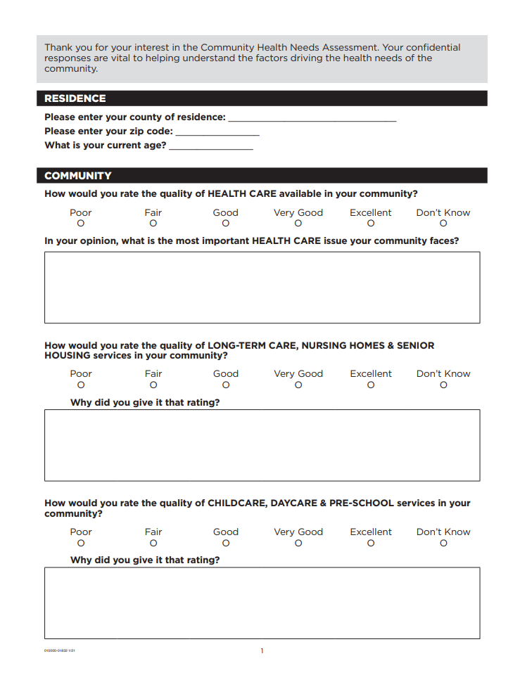

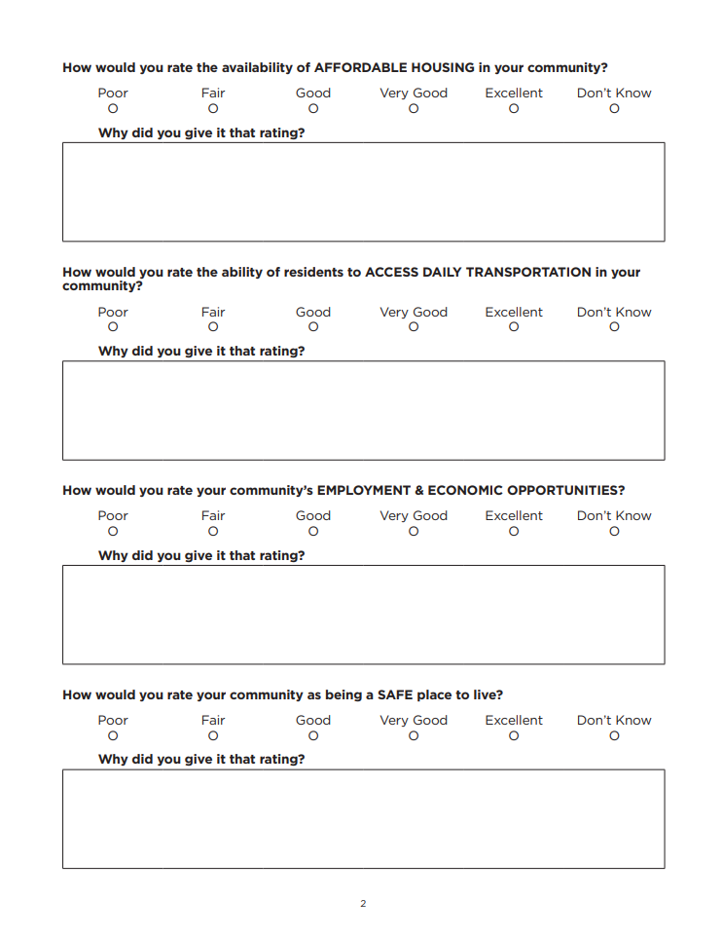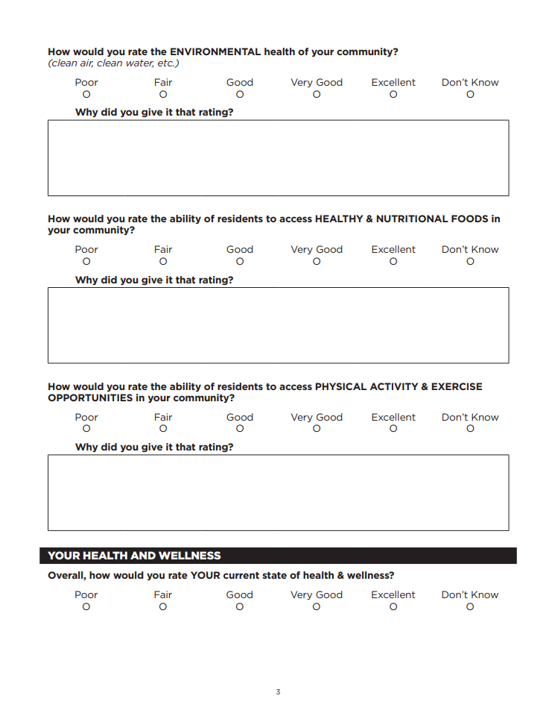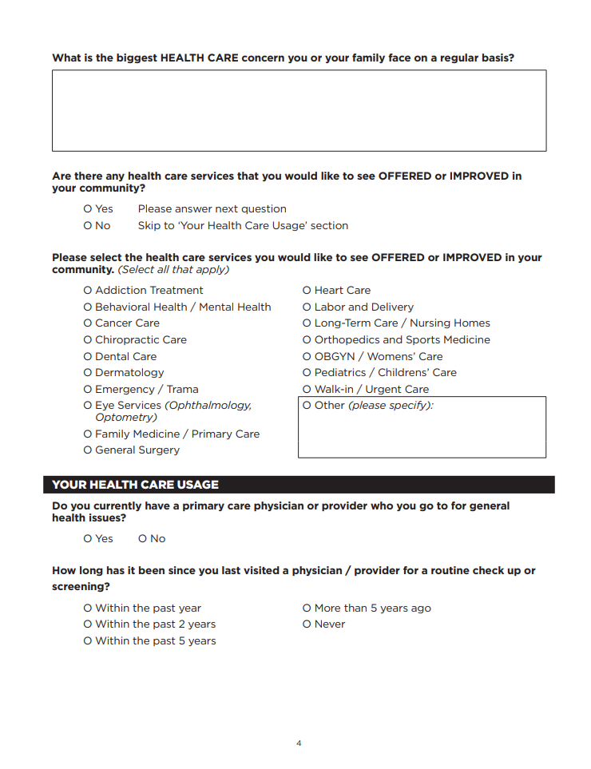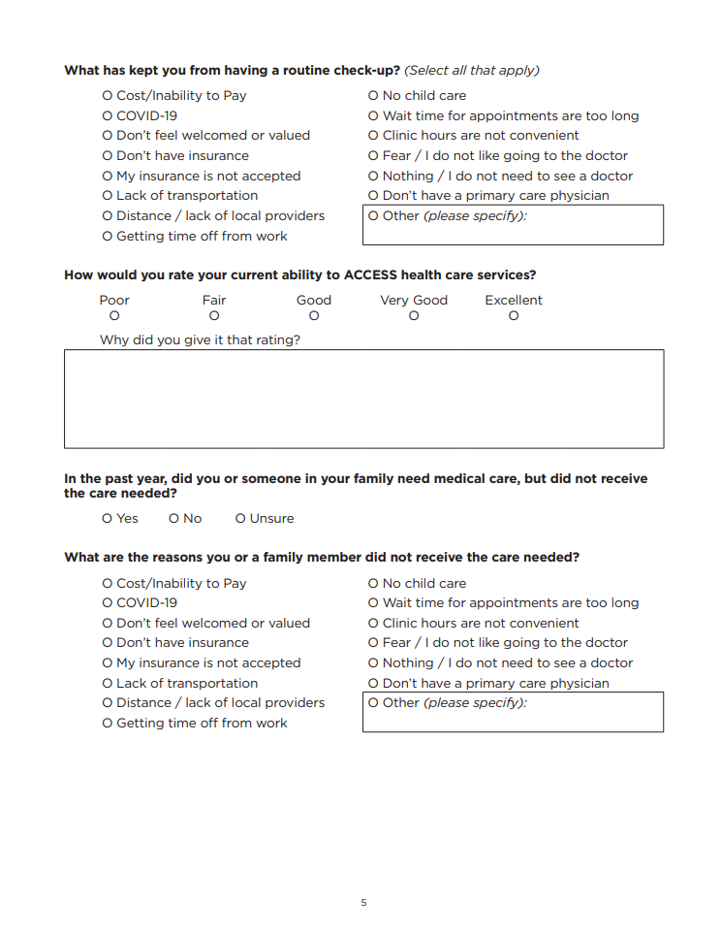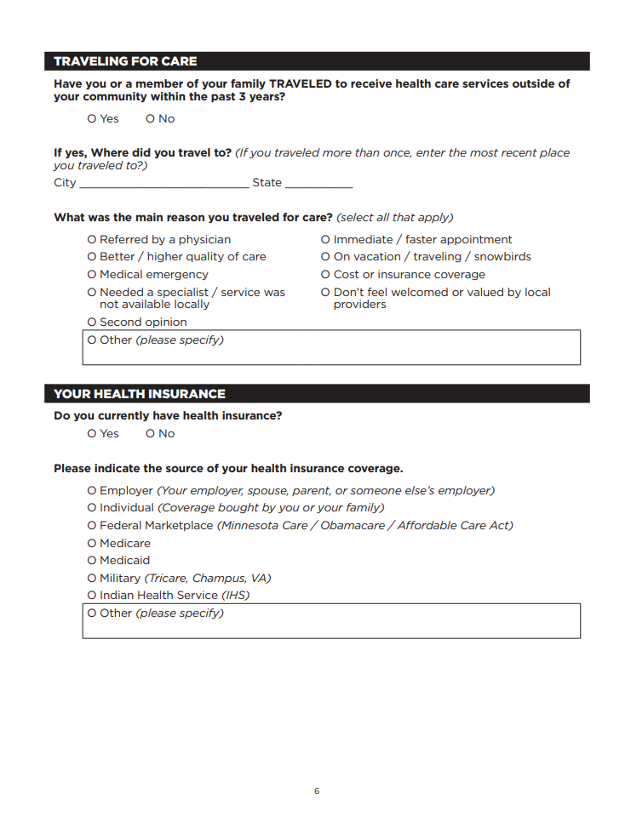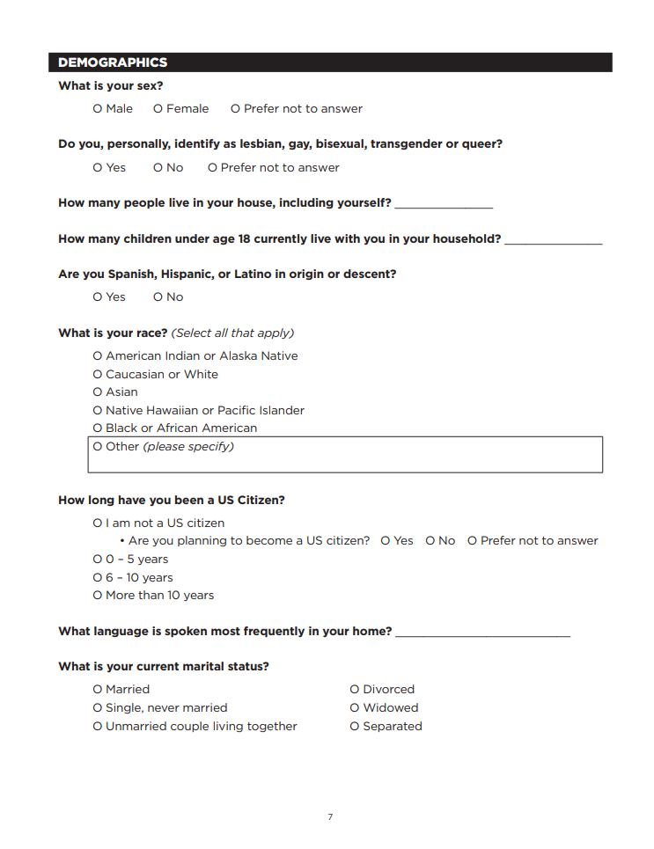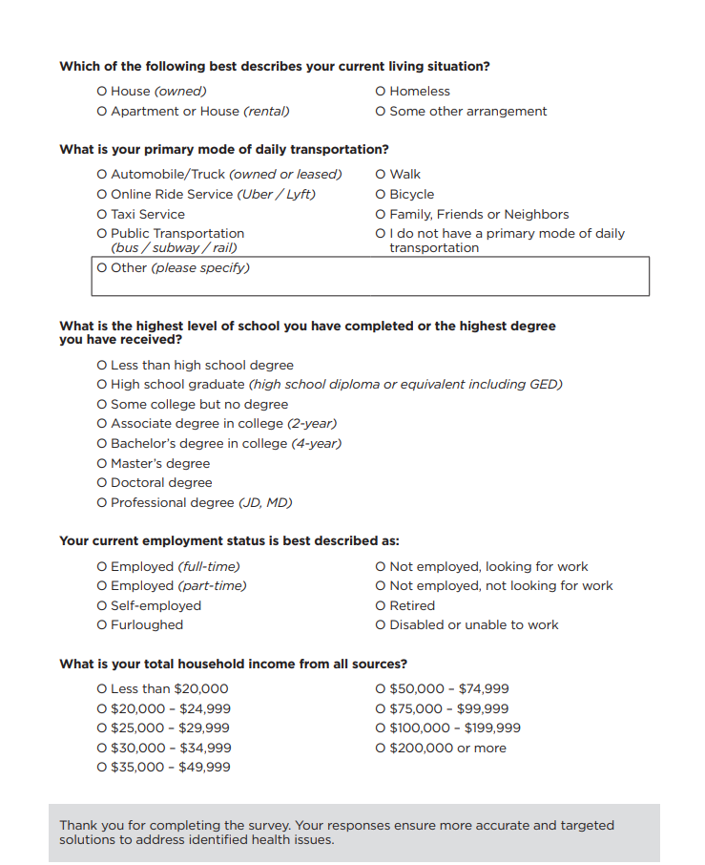

University of Wisconsin Population Health Institute. County Health Rankings & Roadmaps. Available at https://countyhealthrankings.org
University of Wisconsin Population Health Institute. County Health Rankings & Roadmaps. Health Promotion and Harm Reduction. Available at https://www.countyhealthrankings.org/health-data/community-conditions/health-infrastructure/health-promotion-and-harm-reduction
U.S. Department of Health and Human Services. Office of Disease Prevention and Health Promotion. Healthy People 2030. Housing Instability. Available at https://odphp.health.gov/healthypeople/priority-areas/social-determinants-health/literature-summaries/housing-instability
https://www.census.gov/quickfacts

