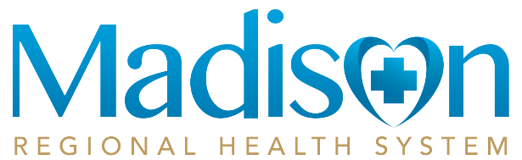

Summary of Financial Assistance Policy
Madison Regional Health System is committed to providing essential healthcare services to Madison and the surrounding communities regardless of ability to pay. To help us strive to achieve this commitment we offer an extensive Financial Assistance Policy.  We offer financial assistance for emergency and medically necessary services provided and billed by MRHS. This assistance ranges from reduction in your outstanding balance to complete forgiveness of the debt. This assistance is offered and provided to those patients demonstrating financial need.  The assistance provided is done so on a sliding scale, based upon verifiable total household income as a percentage of the federal poverty level (FPL) guidelines. Any eligible individual may not be charged more than amounts generally billed for emergency or medically necessary care.  Exceptional Financial Circumstances:  We do consider case by case exceptions for assistance if you provide supporting documentation to show the hardship your medical expenses have caused for you or your family.  Notification of availability of our Policy:  MRHS will make every effort possible to identify those patient’s in need of financial assistance as early as possible. Patients can find information regarding our policy and applications available through (1) Information posted at registration areas, (2) policy, summary, and application available on the MRHS website, (3) the back side of every billing statement sent out monthly, and (4) healthcare providers and staff identifying patient who may be eligible for assistance based on a financial need.  Services Covered:  Services rendered and billed through MRHS for emergency and medically necessary care will be covered under an approved application for financial assistance, dating back to 1 year of the date the application is received by our financial office. We may also consider charges for services provided after our date of approval for up to six months without requiring you to complete a new application. |  | Extraordinary Collection Efforts:  MRHS will make reasonable efforts and attempts to determine a patient’s ability to pay or need for financial assistance before engaging in extraordinary collection activities. Such activities would include: liens on property, attaching or seizing bank accounts, foreclosures on real property, commencing civil action, garnishing wages, and reporting debt to the credit agencies.  How to Request Assistance:  Our application and policy are available on our website http://www.madisonregionalhealth.org under ‘Patients & Visitors’ and ‘Financial Assistance.’ To request a copy by mail, contact the Business Office at Madison Regional Health System, 323 SW 10th St., Madison, SD 57042, or call the Business Office at 605-256-6551. Copies of the financial assistance policy, summary of financial assistance policy and application are available free of charge.  Complete the following documentation and submit it to the Business Office:  - Financial assistance application form signed & dated  - Copies of the two most recent pay stubs for each wage earner in the household.  - Copies of last 1 months bank statements for all accounts (checking, savings, etc.)  - Tax return (federal, state if applicable), if not available, provide one of the following:  - Social Security Awards letter  - Proof of non-filing from the IRS (call 800-829-1040 to obtain a copy)  - W-2(s)  - Copies of all medical expenses  - Copy of your property tax assessment statement from county for all owned property.  - Copies to support assets values (mortgage statements, loan statements, etc.)  The Business Office may request additional information as necessary for processing.  A Financial Counselor is available either in person or by phone for further information, Monday through Friday from 8am to 5pm.

